**North South University**

**Department of Electrical and Computer Engineering**

**CSE 215L: Programming Language II Lab**

**Lab** – **2: Conditional Statement, Loop**

**Objective:**

* To learn to use conditional statements (if, else, switch case)
* To learn the usage of loops (for, while, do-while)

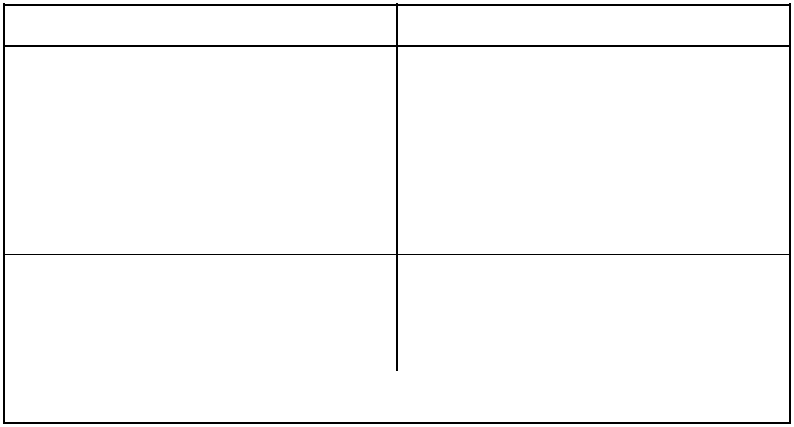

***if-else***

if(condition){

// do something

}

else{

// do something else

}

***Switch***

switch(case){

case 1:

* do things for case 1 break;

case 2:

* do things for case 2 break;

default:

* do things for default case

}

|  |  |
| --- | --- |
| ***For*** | ***while*** |
|  |  |
| for(int i = 0; i < 10; i++){ | while(condition){ |
| // do something | // do something |
| } | } |

**Task:**

1. Write a program that takes an integer and determines if it’s odd or even. Use switch cases to produce result.
2. Write a program that takes an integer and determines if it’s prime or not. A number is prime if it is divisible by 1 and itself only, i.e. 2, 3, 11, 37 etc.
3. Write a program that prints the multiplication table from 1 to 5.

1X1=1

1X2=2

…………

5X10=50

4. Write a program that takes an integer and prints its divisors, i.e. divisors of 12 are 1, 2, 3, 4, 6.